Aim  
To create a snapshot of a Virtual Machine (VM) in Oracle VM VirtualBox and test it by loading the VM from the saved snapshot or cloned VM.

**Procedure**

1. Open Oracle VM VirtualBox
   * Launch the VirtualBox application on the host system.
2. Select the Virtual Machine
   * In the VirtualBox main window, select the VM for which the snapshot is to be created.
3. Create a Snapshot
   * Click on the Snapshots tab on the top right panel.
   * Click the Take button or right-click the VM and select Take Snapshot.
   * Enter a descriptive name and optional description for the snapshot (e.g., "Pre-update Backup").
   * Confirm to save the snapshot. This captures the VM’s current state.
4. Make Changes to VM (Optional)
   * Power on the VM and make some changes (e.g., install software or modify files) to test the snapshot feature.
   * Shut down the VM when done.
5. Restore Snapshot (Load Previous Version)
   * Go to the Snapshots tab again.
   * Select the saved snapshot from the list.
   * Click Restore to revert the VM back to that previous state.
   * Start the VM to verify that it loads the saved snapshot state.
6. Clone the VM
   * In the main VirtualBox window, right-click the VM and select Clone.
   * Choose between Full Clone (independent copy) or Linked Clone (shares disk space with original).
   * Name the cloned VM and proceed with the cloning process.
7. Test the Cloned VM
   * Start the cloned VM to verify it runs as expected, independent of the original VM’s current state.

**Output:**

**Snapshot: Before revert**

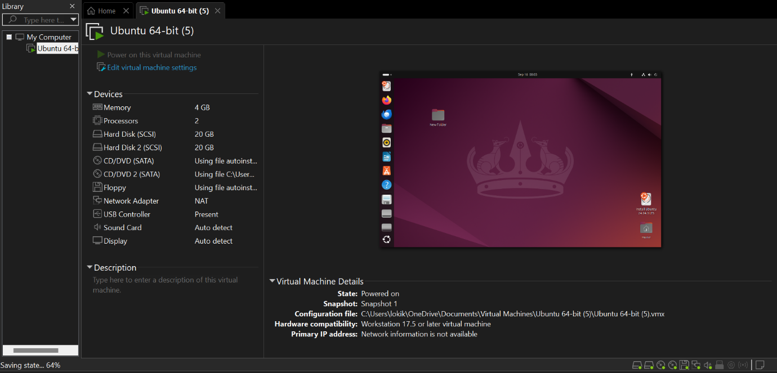

**Snapshot: After revert:**

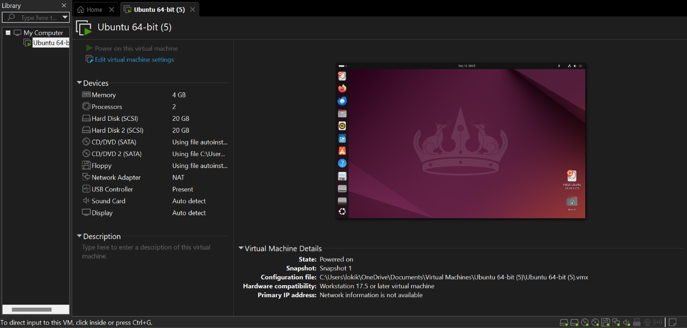

**Result**

A snapshot of the Virtual Machine was successfully created using Oracle VM VirtualBox. The VM was restored to the previous snapshot state, confirming that snapshots allow rollback to earlier configurations. Additionally, the VM was cloned, and the cloned VM was tested to run independently, verifying effective VM versioning and replication.